Varonis PowerShell script instructions

These instructions provide details on how to run 3 PowerShell scripts
- Adding a Varonis Working Share on the Collectors
- Adding the Collectors with a credentials prompt
- Adding the Windows file servers with a credentials prompt
Pre Requisites
- Ensure PowerShell Version 3 is installed on the server you are initiating the PowerShell scripts from
- .NET Framework 3.5 and 4.5 installed on the Collectors
- Varonis service account has local admin access on the Collectors
- Firewall rules are in place between the IDU and Collector and File servers
- UAC is turned off on the Collectors

Running the scripts:
Create Varonis Working Share folder

Step 1:
Running the createWorkingShare PowerShell script
The script creates and permissions a working share on the list of remote collectors specified in the CollectorList.csv file
1. Creates working share folder
2. Shares folder and sets share permissions to Local Admins with full control
3. Sets NTFS permissions to Local Admins with full control

Step 2:

Update these Variables in the createWorkingShare.ps1 file

$colList = "E:\ScriptTesting\BulkAddCollectors\CollectorList.csv" # Location of CollectorList.csv
$workSharePath = "C:\VaronisWorkingShare" # Physical working share path on remote server
$workShareName = "VaronisWorkingShare" # Working share name

Step 3: In the CollectorList.csv under the Hostname column add in the Collectors host names

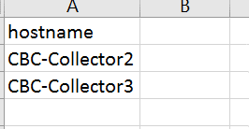

Step 4:
Run the createWorkingShare.ps1 script running as Administrator in the Windows PowerShell ISE
The script should complete with no errors.
To confirm success there should be a VaronisWorkingShare on the Collector
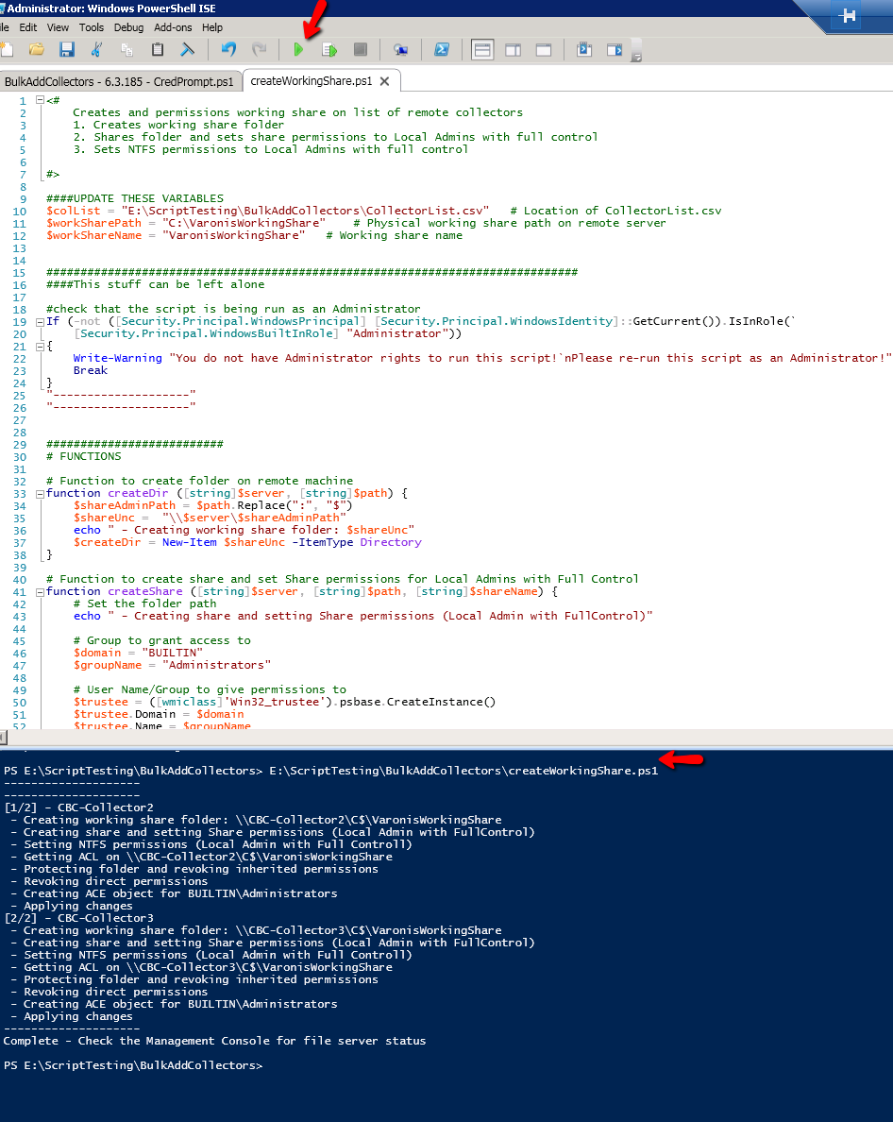

Adding Collectors to Management Console

Note: All Collector Pre-requisites must be met before running this script.

- .Net Framework 3.5 and 4.5 installed on the Collectors
- Varonis service account has local admin access on the Collectors
- Firewall rules are in place between the IDU and Collector and File servers
- UAC is turned off on the Collectors

Step 1:

Update these Variables in the BulkAddCollectors - 6.3.185 - CredPrompt.ps1 file

$colList = "E:\ScriptTesting\BulkAddCollectors\CollectorList.csv" # Location of CollectorList.csv
$workShareName = "VaronisWorkingShare" # Working share name (must be the same on all Collectors)

Step 2:
Run the BulkAddCollectors - 6.3.185 - CredPrompt.ps1 script running as Administrator in the Windows PowerShell ISE
- The script will prompt for details for the Collector Working Share. The Varonis service account details will be required
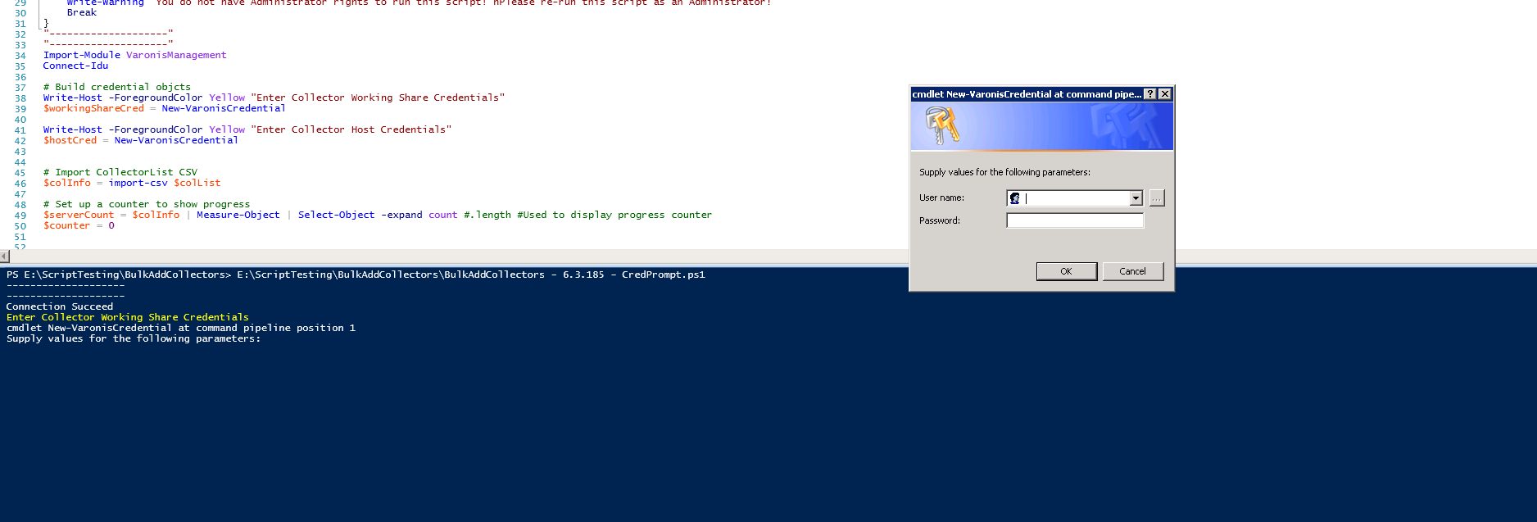
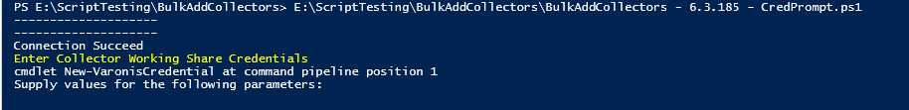
- The script will prompt for credentials for the Collector Host Credentials. The Varonis service account details will be required
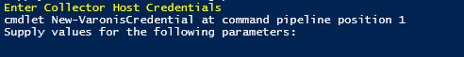
- The installation will start. You can look into the C:\Program Files (x86)\Varonis\DatAdvantage\IDU Server\Logs\Deployment on the IDU server to see Progress as well in the Management Console under the category Deployment
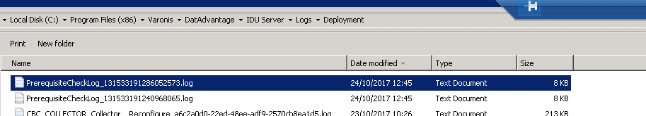

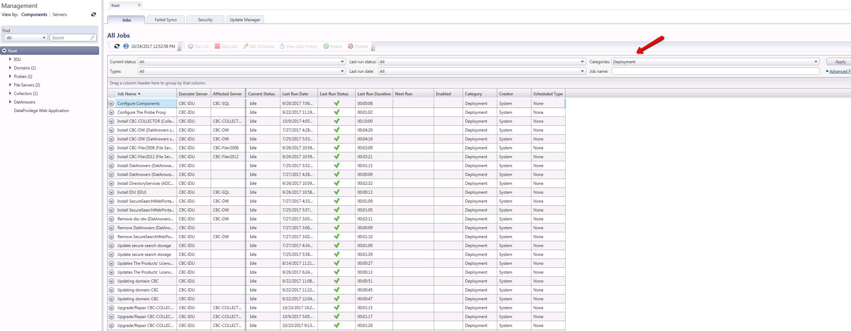

Adding Filers to the Collectors
Note: The Collector must be added to the Management Console before running this script
Instructions:
Step 1:
Update the '$filerList' and '$statusList' variables below:
- filerList: csv containing list of filers and associated collector.
- statusList: general commit log showing success/failure messages per filer
Step 2:
Update the Example_FilserList.csv with the name of the File server and the Collector it will be connected to.

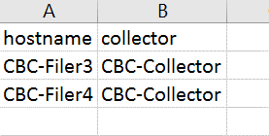
Step 3:
Run script as Administrator
The script will prompt for Filewalk, Agent install credential (the script is set not to install the agents), SQL host, database, and Collector credentials
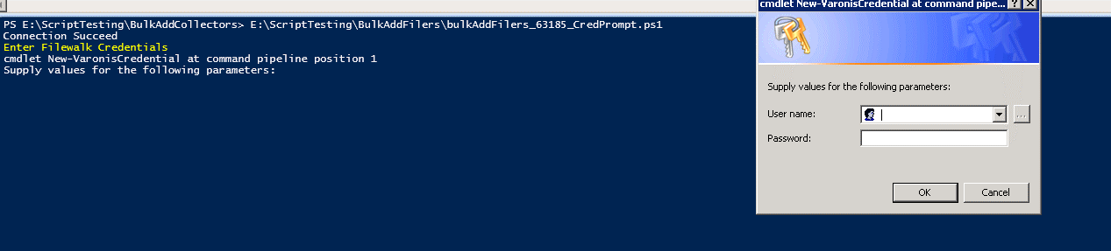
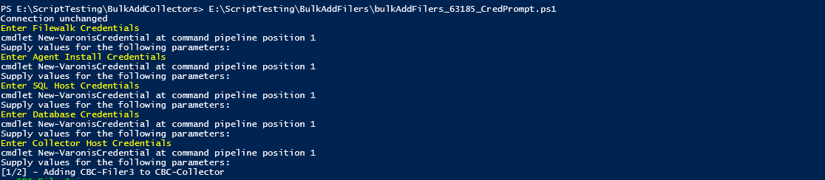

Step 4:
View Management Console for filer install progress under the Deployment category
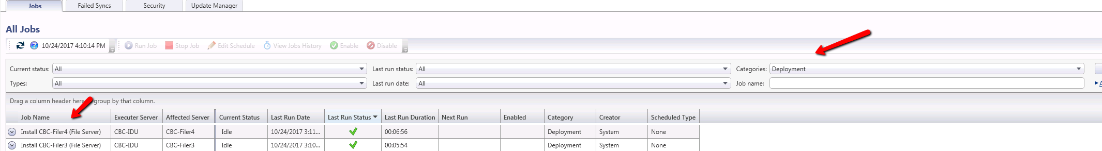
You can also confirm successful install of the file sever in the Management Console
